LAB # 06
“ DEEP LEARNING FOR HOUSING PRICE PREDICTION ”

- OBJECTIVE:
In this lab, you will learn how to use neural networks to predict housing prices using the Boston Housing dataset.

- LAB TASKS:
TASK 1: Try using different scalers like MinMaxScaler() and compare results:

- CODE:
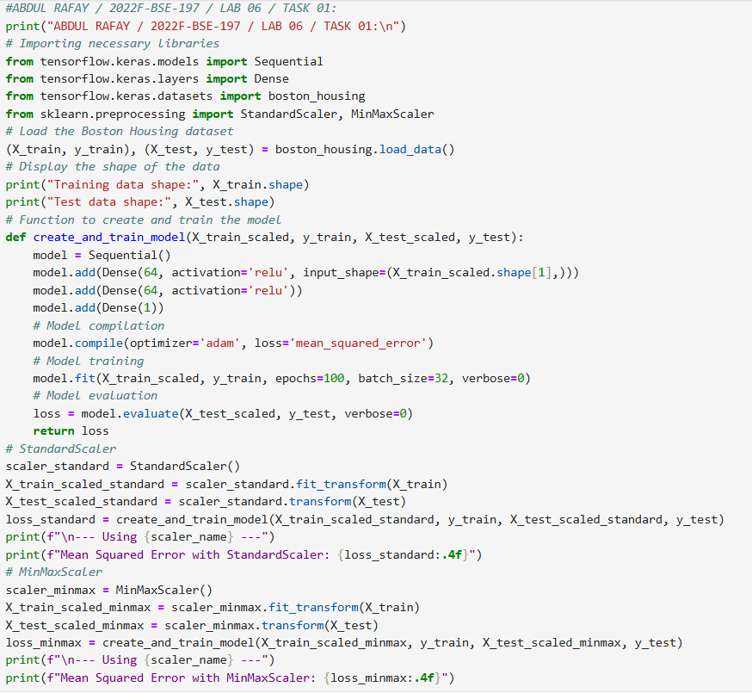
- OUTPUT:
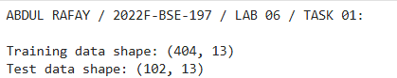
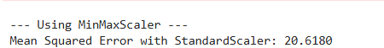
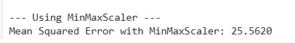

TASK 2: What happens if you don’t normalize the data?
• Try training the model on raw (unscaled) data.
• Compare the training loss and test error with and without scaling.
Visualize the distribution of a feature before and after scaling using a plot.

- CODE:
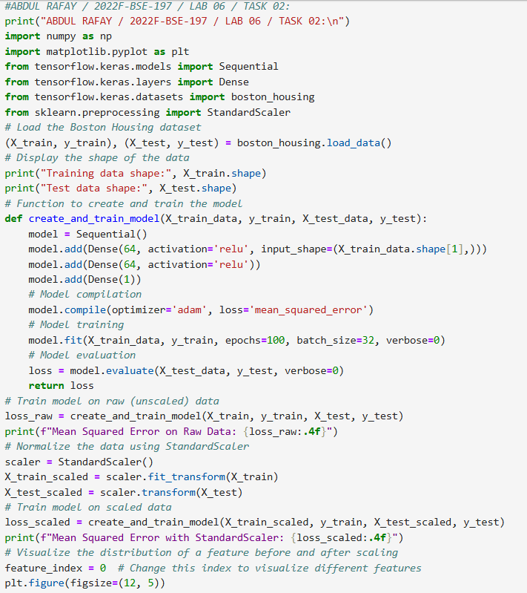
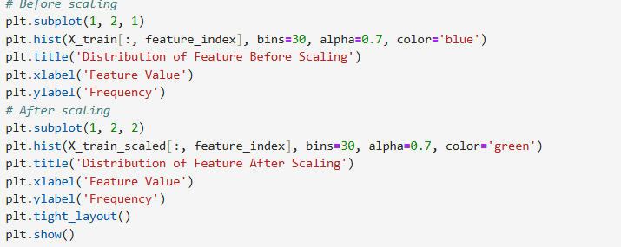
- OUTPUT:
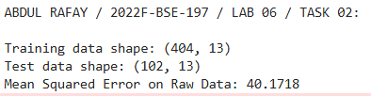
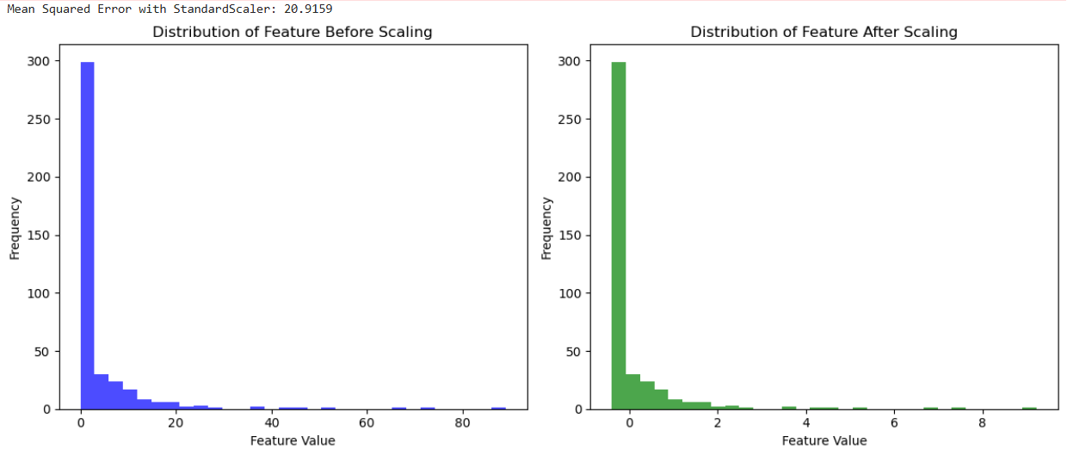

TASK 3:Change the dataset from `boston_housing` to `fetch_california_housing` and observe the results.

- CODE:
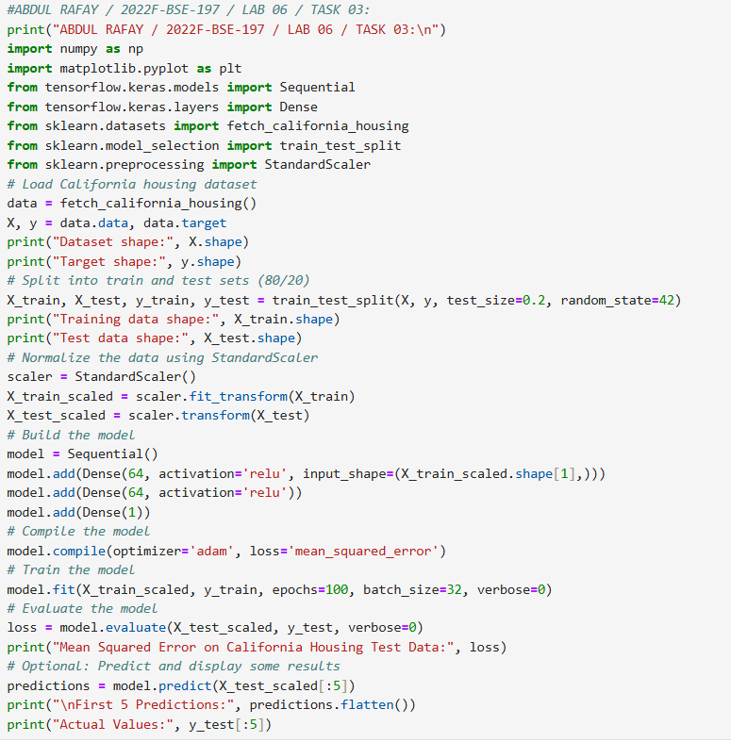
- OUTPUT:
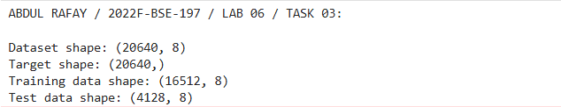
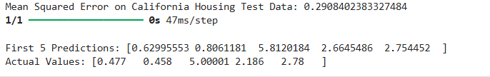

- GITHUB UPLOAD:
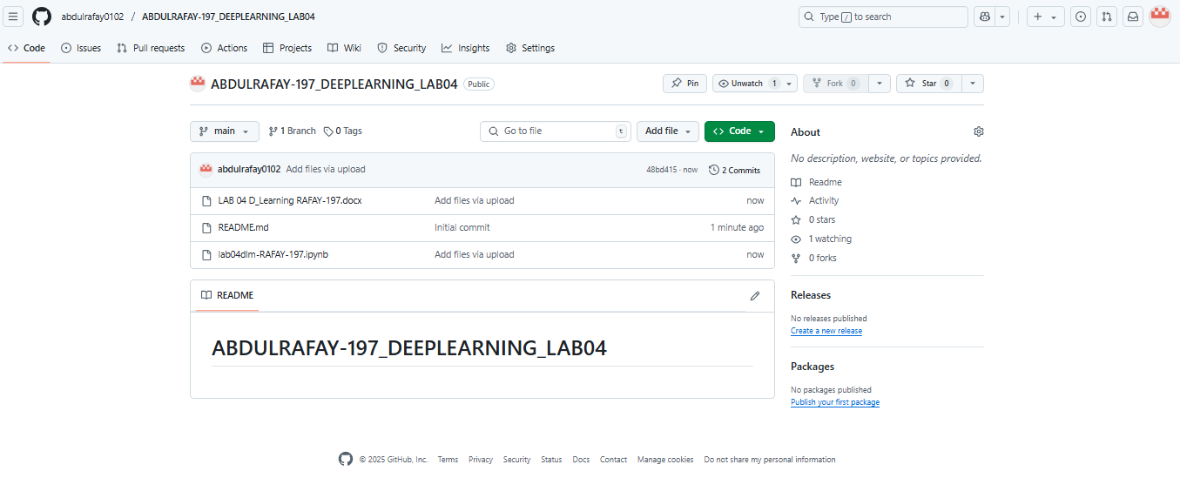
- KAGGLE UPLOAD:
